The Influence of the Use of Website-Based Learning Media on Engineering Drawing Materials

Tuti Suartini Aan Sukandar ,Fikram Fauzul Zadi, Anggraili Salsabila Fikadinda,Wahid Maulana
Universitas Pendidikan Indonesia

tutisuartini@upi.edu

Abstrak
The era of digitalization actually offers various conveniences. Learning can be done through various methods, not only conventional methods. The widespread use of the internet network must be utilized optimally in various fields. So that digital technology is very functional today to do online learning. The influence of the production of learning media with website-based technology on responses to the learning activities of the Engineering Drawing course, Mechanical Engineering Education Department. Learning media used through the web aims to be used as alternative teaching materials in the learning process in the hybrid learning era. The technology used allows users to access it on any device that has an internet network without having to eat up storage on the device, because the media only uses the internet network to access it. In the research conducted using quantitative descriptive methods. The results showed that the media user response results obtained a percentage of 80.54% which could be categorized as very good. Based on the conclusions of the research results, this web-based learning media is feasible to use because it can help the teaching and learning process both offline and online
Keywords: Influence, Learning Media, Digitalization Era, Website, Technical Drawing.
INTRODUCTION
The development of technology has an impact on changes in the field of education capable of changing the way a person obtains information. The use of learning media in the field of education is part of one that can be assumed to affect the quality of an education. Information systems and communication technology can now be used as interactive learning media. The method used in the teaching and learning process that is equipped with ICT in delivering material or information to students from various studies shows more effective results than using non-ICT media. This is one of the new learning media that has been used during teaching and learning activities due to the Covid-19 pandemic which is popularly known as online learning and is very effective and efficient to use during the COVID-19 pandemic, which is to avoid gathering activities and maintain distance.
Activities remotely to avoid potential crowds carried out by the World Health Organization (WHO) have provided recommendations for efforts to prevent the spread of the Covid-19 outbreak. The guidelines for implementing the learning process during the pandemic as outlined in the Decree of the Minister of Education and Culture Number 03/KB/2021 can be implemented in higher education teaching and learning activities in Indonesia, starting from the beginning of 2022, limited face-to-face meetings while still complying with applicable health protocols. Education is one of the efforts to make humans able to survive in their environment and in all their life situations. Students and students must be able to study in all circumstances that occur, therefore learning must continue in all conditions(Redja, 2004).
The development of ICT technology which is very useful to support the learning process is not only computers and laptops, smartphones, cellphones which are usually owned by students can already be used as learning tools or media. So learning activities can be carried out anywhere and anytime, especially when information and communication technology connectivity has almost reached all corners of Indonesia. The quality of education that can successfully increase is education that is able to adapt to technological developments (Rusman, 2012).
The use of the internet and multimedia technology can change the way knowledge is presented and can be used as an alternative in the learning process (Zhang et al., 2004) The challenge that applies to the application of ICT technology in distance or online learning in the field of vocational education is whether it can be done online learning for fields that require hands-on skills training. The extent to which ICT technology used in online learning can be an innovation that changes a learning method that was originally done conventionally to become more modern through website development. The results of research by Gheytasi, Azizifar and Gowhary in (Khusniyah & Hakim, 2019) stated that, in several other studies they reviewed showed that the application of technology in the field of education had a positive influence on learning.
The positive influence created is supported by the integration of the internet in learning media, so that teaching and learning activities can run more effectively and easily. Online teaching and learning activities are a distance learning system implemented by utilizing online media. The purpose of online learning is to facilitate the activity of delivering learning materials while still paying attention to the quality of the network. The achievement of distance learning goals through the use of network technology has a major impact in the field of education (Korucu & Alkan, 2011). The most widely used media to support the implementation of online learning is the website, especially during the pandemic.(Istiqomah et al., 2021). From various online learning studies, it shows that there is a positive influence and there is also a negative influence, so for this study to review how the influence of Web site learning media in teaching and learning activities for Engineering Drawing subjects ?
There is a time when there is a massive spread of the virus, there is a rapid spread and we must keep our distance and so on. The Engineering Drawing course is one of the practical courses at the college level of the Mechanical Engineering expertise program held at UPI for online learning. The learning process during the pandemic period which only conducted face-to-face using internet or online network media and could only do lectures, the next discussion was given a task. Students who have to go through online engineering drawing courses are class 2018 and class 2019 and most of these students do not have basic skills in engineering drawing lessons, especially students from high school. With the background of not getting the basic skills of Engineering Drawing lessons, whether it affects the mastery of other mechanical engineering fields of study, this is something that is important to study. Engineering Drawing course is a means and language to communicate in the field of engineering technology. This Engineering Drawing course requires a demonstration/tutorial how to draw so that students can understand the principles of engineering drawing. Web site technology is ICT learning media technology that has been used before the covid pandemic, so the extent to which online learning in this engineering drawing course affects students' abilities and what factors are the obstacles in the learning process in the engineering drawing course.
LITERATURE REVIEW
Developing materials for Web-based learning for various learning methods may be worth the effort, in fact there is no doubt that it can be time consuming and expensive or even more effective and efficient. Web-based learning is a time-consuming and expensive proposition. In addition, most of this learning development is carried out at the local level with similar subject matter being developed simultaneously in various learning institutions.(Smith, 2006).
- Website-Based Learning Media
Media in language literally has a middle or intermediary meaning (Arsyyad, 2019) (Azhari, 2015) and is used as a means of delivering messages or information in learning activities whose target is to arrive at information (Maknun, 2017). With the understanding that learning media is a tool used to assist teaching and learning activities and has a function to clarify the information to be conveyed, so that the teaching and learning process can achieve its goals.
There are various media that can be used in the delivery of educational content: text (print, including graphics), audio (analog), video (analog), and digital multimedia. Digital multimedia is a technology that can be used to transmit media. Bates identified that the main distinction made in the technology used to transmit digital multimedia is that it is a one-way technology that transfers information from the producer to the receiver, but does not include a two-way interaction mechanism. The development of communication technology facilitates today's communication to occur equally back and forth between all participants which can be done technologically synchronous versus asynchronous. Synchronous technology operates in real time; all parties must participate simultaneously. Asynchronous technology allows participants to choose a time and place that is convenient for them. Table 1. shows how different digital multimedia technologies are included in these two structures.

Table 1. Multimedia Technologies Adapted (From Bates and Poole. Effective Teaching 55)

 | TECHNOLOGIES
 | Broadcast (one-way) applications |  | Communication (two-way) applications
 | Synchronous | Asynchronous | Synchronous | Asynchronous
Digital Multimedia | Webcasting  Audio Streaming  Video Streaming | Websites  CD-ROMS  DVDs  Learning Objects  Multimedia Clips  Blogs | Chat  MUDs  Web Conferencing  Voice over IP (VoIP) | E-Mails  Discussions Forums

- Multimedia-based Teaching Materials
Education experts in Indonesia say that the function of media and learning media(Arsyyad, 2019) can be said to be a messenger technology that can be implemented into the learning process in the form of print media, communication media including television, films, photos, recordings, projections, and magazines used for learning purposes, both physical and non-physical.
Learning media can be used appropriately in accordance with the objectives, materials, indicators of expected achievement after the learning process takes place. Message delivery tools through ICT media technology have now become a necessity in ongoing learning activities in the digital era that do not limit learning because there are time and space limits. The sender to the recipient so that the recipient can understand or more easily open his mind, feelings, interests and attention to whatever is conveyed by the media. Media are tools, methods, and techniques that can be used as a means of communication and interest, between students and educators in the teaching and learning process.
It can be concluded, learning media has changed, starting from different ways of communicating and relating using digital and ICT era technology and different ways of doing learning. The readiness of educational institutions with big challenges must make changes. How can we ensure that we develop the types of graduates from our courses and programs that are suitable for an increasingly turbulent, uncertain, complex and ambiguous future? What should we continue to protect in our teaching methods (and institutions), and what do we need to change? based around the industrial age rather than the digital age (Bates, 2015) and Online Collaborative Learning (OCL) learning or the development of online media websites will be successful if the teacher's abilities are supported by school situations and conditions that are in accordance with the required infrastructure (Suartini, 2019). How is the position of a teacher in the OCL knowledge community as shown in Figure 1 below

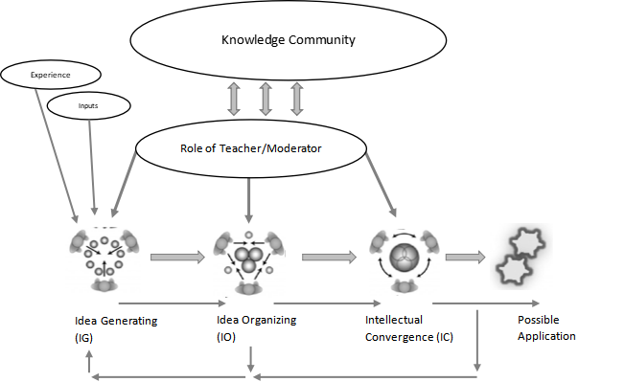
Figure. 1. The position of the teacher in OCL learning (Harasim, 2017)

Through the website learning media, Figure 1. Techniques are not a tool to express ideas or ideas of technical experts but also become teaching materials that can be developed in OCL learning. Through the website learning media, Figure 1. Techniques are not a tool to express ideas or ideas of technical experts but also become teaching materials that can be developed in OCL learning. Technical Drawing learning media are teaching materials that aim to instill basic technical competence on image standardization, image function, image projection to realize machines in the real world into a scheme that can be used to design innovations for the development of machines in order to ease human activities (Juhana & Suratman, 2000). Engineering Drawing materials for the field of machinery that are delivered online are only part of the tools or technology-based media for learning (Sukandar et al., 2020). In the real world context and in the end requires the existence of Laboratory, Workshop or Studio Work; Apprenticeship; Problem Based Learning; Case Based Learning; Project Based Learning; Inquiry-Based Learning; Cooperative Learning (Work Or Community Based).
The use of multimedia that will involve student activities needs to be based on knowing the advantages and obstacles that will arise in the learning process. Gerlach & Ely say that the use of multimedia that will involve student activities needs to be based on knowing the advantages and obstacles that will arise in the learning process. Multimedia has fixative, manipulative and distributive abilities, although there are still obstacles in verbal communication, misinterpretation, lack of focused attention and frequent misinterpretations because there is no explanation (Grabowski, 2003). So the presentation of learning multimedia needs to be based on tutorials, drills and practice, multimedia simulations, experiments and concept formation games.
The use of multimedia in the learning presented must be structured, attractive, in harmony with the material displayed such as the concept of pictures, rules and provisions of the image required to be able to equalize perceptions among students by designing creative multimedia according to learning needs (Arsyad, 2019). Online learning that uses the concept flow as shown in Figure 2 below if carried out using a website, multimedia or ICT technology for academic and conceptual development, discussions need to be well organized by the teacher, and the teacher will provide the necessary support to enable idea development and construction. new knowledge for students (Bates, 2015).

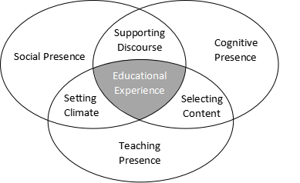

Fig 2. Community of Inquiry
The development of technical drawing materials in the digital era which is designed as shown in Figure 2 above shows that broadcast/communicative and synchronous/asynchronous are two separate dimensions and the placement of media technology in the image matrix in different quadrants as shown in Figure 3 below as learning media that can also be applied to online learning models known as the internet as a means for website development that can be used to deliver learning materials.
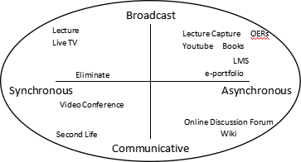
Fig 3. Internet
Ritchie and Hoffman identify the following: the sequence that is considered important for the instructional process is to provide learner motivation, visual and multimedia elements that can contribute to motivational factors and can incorporate components such as problem solving opportunities, critical thinking exercises, and relevance to learner needs. Being able to offer reviews to build their knowledge and active engagement is more than just clicking on a hyperlink to browse the site. Testing the material delivered through the web site is still a way that teachers must still do to find out whether students have learned what has been taught. Website technologies that can be used for teaching materials for technical drawing materials are:

1. Ispring suite
Currently, there have been many developed software and hardware that can be used in learning. One of them is the ispring suite software. Ispring suite is a tool for converting presentation files into flash slides that is integrated with PowerPoint to create an effective e-learning program. This Ispring suite presents teaching materials in the form of flash slides which can contain images, animations, videos and audios that can be used as an alternative to create interesting learning media, so that they can help teachers/lecturers in delivering subject matter become more interesting, practical and optimal.
2. Website
A website (also written as a website) is a collection of web pages and related content identified and published on a single web server. Examples of well-known websites are Google, Facebook, Amazon, and Wikipedia are websites that are commonly used for activities on the internet. A website is a collection of interrelated web pages to provide certain information, which can be accessed via a domain name on the internet using a web browser application (Chrome, Firefox, etc.). Websites that are familiar in the ICT era can be accessed through electronic devices such as computers, laptops or cellphones, where on the website there are various forms, such as templates, displays and designs that can be used for various needs related to activities through online media. WEB is a combination of content which includes images, text or videos that are packaged into a page, which is stored on a computer server that can be accessed by internet networks. Every website has an address to access, which is usually called a URL (Unifrom Resource Locator ).

3. CAD (Computer Aided Design) AutoCAD
CAD is an abbreviation of Computer Aided Design which serves to assist human work in the field of design, or rather an application to help depict a product, before the product is produced. One of the CAD applications that is often used as the basis for lecture materials based on machine technology is known as AutoCAD. To be able to create machine drawings using AutoCAD, CAD can represent drawings with patterns of lines and symbols that arrange each other and side by side that form a pattern that forms a 2-dimensional image or 3D image. So that the schematic projection to be a guide in realizing a machine will be more accurate than manual drawings.

METHODS
In the study, teaching materials were prepared which were developed by the ADDIE research model developed by Dick and Carey (1996) to design a learning system that uses five development steps, namely: Analysis, Design, Development, Implementation, Evaluation. ADDIE with situation scenarios used for educational product development (Brinkerhoff, 2001).

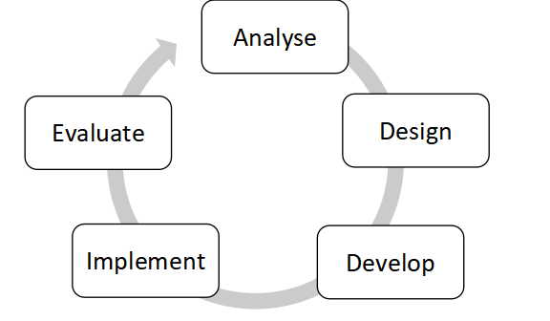
Fig 4. Model ADDIE
The stages of developing the ADDIE model in the picture above are used to design teaching materials for Engineering Drawing materials that will be delivered through a website application as shown in Figure 4. The stages developed according to the picture above are making an analysis of (A) material needs, student characteristics and software analysis used, making designs (D), covering the design of the media framework, preparing teaching materials and making evaluations, as well as displaying application designs or other types of learning media, developing (D), which is a process that includes the stages of making products, in addition to product validation. before doing the test. Furthermore, in the final process to determine the influence of web media, it was studied from carrying out the trial phase of the application of media to students and the results of evaluating (Evaluate), from the process that continues to be carried out at each stage of the implementation of teaching materials delivered in the learning process activities.

The population of the research carried out was carried out on students with a sample of 30 students from the class of 2020. who were carrying out the Engineering Drawing course. The sampling technique in the form of media testing is needed by students who are taking Engineering Drawing courses, and are affected by a pandemic/online learning Dick and Carey. To determine the effect of learning media that involves all students who take the course.

RESULT AND DISCUSSION

Engineering drawing learning material using a website that begins with data collection, analysis of the quality of the facilities, obtained data stating that the development of teaching materials via the internet is still constrained in aspects such as being difficult to access with a slow internet network to open applications, the audio on the video is not large, and so on. -other. This happened before testing the instrument. With this fact, the research conducted at the design stage of the research instrument of media testing tools has high validity and reliability so that it can be trusted. Based on the results of the analysis of the means for presentation that have been revised. Assessment of the results of web site design for learning materials obtained validity of 0.463 with the results of reliability calculations 0.93 and strengthened by expert judgment, so that the material used as teaching material in the Engineering Drawing course is good.
The quality of teaching materials and materials designed in web-based learning media are designed according to the revised evaluation results and teaching materials that are ready to become products can be seen in the pictures below:
ENGINEERING IMAGE MATERIALS IN WEBSITE LEARNING MEDIA
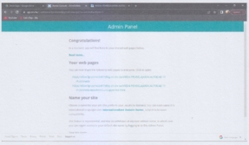
Figure 5. Website Drive To Web
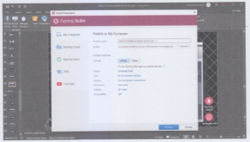
Figure 6. Media Display When Accessed by Website
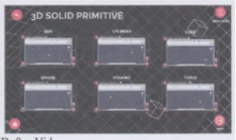
Figure 7. Video List Display

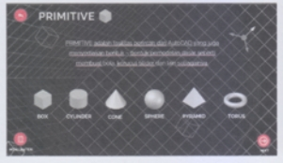
Figure 8. Display Material Menu

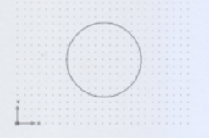
Figure 9. 2D object display, xy isometric
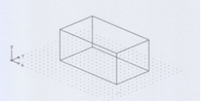
Figure 10. Display of 3D objects, xy plane
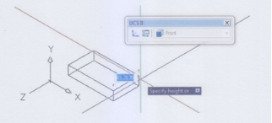
Figure 11. Example of creating an object with the direction of movement
front rear extrusion

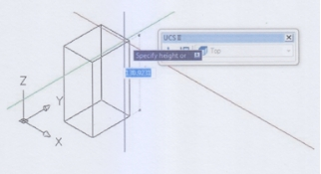
Figure 12. Example of creating an object with the direction of movement
top down extrusion
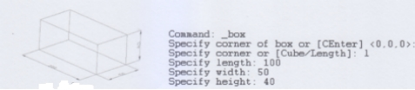
Figure 13. Making a box with a length of 100 mm,
width 50 mm and height 40 mm

The presentation of teaching materials from pictures 5, 6, 7, 8, 9, 10, 11, 12 and 13 is delivered through the website learning media in the learning activities of the technical drawing course. Based on the results of data collection through questionnaires, it can be seen that the presentation through the web site media can affect the quality of learning. The quality of the technical drawing material delivered through the learning media received a very good response. The results of the responses evaluated by a sample of 30 students regarding aspects of evaluation indicators are as shown in table 2 below.

Table 2. Response Value of Presentation of Technical Drawing Material
Using Website teaching materials

No. | Assessment Aspect | indicator | AVAREGE
1. | Learning materials | Suitability with learning objectives | 80
1. | Learning materials | Presentation of material discussion | 84
1. | Learning materials | Increased curiosity | 82
1. | Learning materials | Description delivered | 80
2. | Media display quality | The use of sentence structure in delivering material | 78
2. | Media display quality | Use of communicative language | 79
2. | Media display quality | Use of easy-to-understand language descriptions | 80
2. | Media display quality | Presentation of examples in pictures | 83
2. | Media display quality | Presentation of the suitability of video images with introductory language tutorials | 80
3. | Learning process | Improvement of learning motivation | 81
3. | Learning process | Increased interest in learning | 79
 |  | Average rating of Media quality | 80.54 %
 |  | Median value | 80

The development of this WEB-based learning media uses the ADDIE (Analysis, Design, Develop, Implementation. Evaluation) development model. Based on table 1 above in graphic form, it can be seen in Figure 14.
Figure 14 shows that the discussion of material through the website learning media gets the highest response and for the delivery sentence structure shows the lowest value. This shows that in the structure of delivering sentences there are other factors that can be said to depend on the skills of the teacher and becomes an interesting matter for further research.

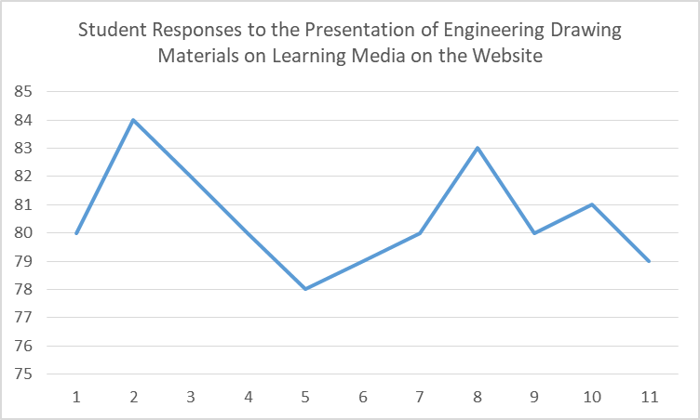

Figure. 14. Description of the response to the technical drawing
material on the Website

The development is carried out in stages with the ADDIE development model by applying the first step, namely Analysis, which is a stage that includes activities to collect initial information needed in the process of developing WEB-based learning media. After discussions with the lecturers and the results of interviews from several students, in the engineering drawing course, projection material is one of the materials that requires interactive learning media. Needs analysis in making learning media produced is made by not consuming smartphone or device storage used by users, because it is considered burdensome, if there is no storage left. Then use software such as Power Point, Ispring Suite, Google Drive, and Movavi to create the learning media.
Needs analysis in the first stage of designing materials and content, the materials contained in this WEB-based learning media include; understanding, layout of tools, various tools, and how to use tools. The material in this WEB-based learning media is presented in the form of writing, images and videos. And at the product design stage, the media design is in the form of a storyboard that serves as a reference for making user interfaces in this WEB-based learning media.
In the Development of a series of processes for making WEB-based learning media starting from making background images, opening media, making opening menus, making menu series, entering material and content, and making learning videos to validate research instruments. Based on the results of the expert judgment, it was concluded that this WEB-based learning media was categorized as "Very Appropriate" with notes in the form of comments and suggestions that were used for improvement in the next stage.
The ADDIE development method is the Implementation stage or the implementation stage of the developed learning media. WEB-based learning media was piloted to students of the 2020 Mechanical Engineering Education study program conducted online. The assessment is carried out using a Google Form to provide an assessment of the media to be used.
The last stage in the ADDIE method is Evaluation. Evaluation is the stage of analyzing the data generated at each stage in the ADDIE method. In this study, the evaluation carried out was a formative evaluation including data processing on student responses. Where the results obtained are categorized as "Very Good". In addition, descriptive data generated from expert judgments and student responses in the form of suggestions and comments are processed into references for product revisions that aim to improve this WEB-based learning media.
The results of students' responses to WEB-based learning media are in line with Wahid's opinion (2018), that a learning media is not only a tool, but learning media must be able to increase students' curiosity about the material to be able to provide other experiences that are not easily obtained, and can provide more varied learning methods, in this case students are served by learning media that can be used on any device, especially smartphones. This WEB-based learning media is structured so that it can be accessed easily and does not reduce smartphone storage by storing it. In line with (Ryan & Gottfried, 2012) that in compiling learning methods that are likely to be of great interest to students, one of them is the need for easy access to available media with smartphones that students have. This WEB-based Learning Media, only requires an internet network to access it, making it very easy to use.
Learn more about this source text. Source text is needed to get additional translation information. Send input. Side panel. The use of WEB-based learning media is in line with what was conveyed by (Sadiman, 2012) namely the media can clarify visual messages, overcome the passive nature of students, overcome space limitations, time and senses as well as providing the same stimulation and can equalize the perceptions of students towards the content of the lesson. This WEB-based learning media can also be one of the learning media that is applied visually to online and offline learning though.
This learning media is made with the general principles as stated above. This is done so that the learning media developed has the principles and quality of media that are feasible to be implemented. Although sometimes these existing methods do not work effectively, there is increasing interest among educators and researchers in introducing more useful methods to enhance the teaching and learning experience. Along with the increasingly widespread digital technology in recent years, the integration of technology has influenced the way or method in the learning process. The challenge faced by students is that changing the conventional education system to a virtual format takes a very long time. The use of technology in this learning media is highly recommended for developments in the field of engineering education. Based on these results, this WEB-based learning media will be able to display pictures from software that can increase interest, especially interest in learning independently.
Conclusion
Based on the results of research that has been carried out on the development of WEB-based learning media in the Engineering Drawing course, it was concluded that WEB-based learning media were developed using the ADDIE (Analysis, Design, Develop, Implementation. Evaluation) method based on feasibility testing carried out by experts or from expert judgment, the learning media developed got a score that was categorized as "Very Appropriate" so that it could be used as an alternative learning medium in the Engineering Drawing course. The material presented via the web can be delivered in an attractive manner and can increase learning motivation and interest in learning Engineering Drawing courses. WEB-based learning media is relevant to the development of ICT-based learning media technology and can be used as a learning medium for lectures online or offline. By only having a gadget that is owned and connected to the internet, this media can be accessed easily.
6. Referensi
Arsyyad, A. (2019). Media Pembelajaran (21st ed.). Rajawali Pers. http://katalogarpusdabrebes.perpusnas.go.id/detail-opac?id=17681
Azhari. (2015). Penerapan model pembelajaran discovery learning terhadap peningkatan hasil belajar siswa kelas XI-IPA1 pada materi sistem pernapasan di SMA Negeri Unggul Sigli. Jurnal Biologi Edukasi, 7(1), 13–21. http://jurnal.unsyiah.ac.id/JBE/article/download/5487/4605
Bates, A. T. (2015). Teaching in a Digital Age Teaching in a Digital Age. Creative Commons Attributions Non-Commercial …. http://solr.bccampus.ca:8001/bcc/items/6e34af22-19b4-4271-9337-8ee1160d85ec/1/?attachment.uuid=ede11f4f-4f5d-42e9-a70d-5d5f038262c0
Brinkerhoff, D. A. (2001). Survey of instructional development models, third edition. In TechTrends (Vol. 45, Issue 1, pp. 48–50). https://doi.org/10.1007/bf02763388
Grabowski, S. (2003). Teaching & Media: A Systematic Approach The Gerlach & Ely Model.
Harasim, L. (2017). Learning Theory and Online Technologies (2nd Editio). Routledge. https://doi.org/https://doi.org/10.4324/9781315716831
Istiqomah, Umroh, H., & Wahyuni, W. (2021). Pembelajaran Daring di Tengah Wabah Covid-19 (Online Learning in the Middle of the Covid-19 Pandemic). Prosiding Seminar Pascasarjana UIN Sulthan Thaha Saifuddin Jambi Program Manajemen Pendidikan Islam, 1(1), 122–135.
Juhana, O., & Suratman, M. (2000). Menggambar Teknik Mesin. Pustaka Grafika.
Khusniyah, N. L., & Hakim, L. (2019). Efektivitas Pembelajaran Berbasis Daring: Sebuah Bukti Pada Pembelajaran Bahasa Inggris. Jurnal Tatsqif, 17(1), 19–33. https://doi.org/10.20414/jtq.v17i1.667
Korucu, A. T., & Alkan, A. (2011). Differences between m-learning (mobile learning) and e-learning, basic terminology and usage of m-learning in education. Procedia - Social and Behavioral Sciences, 15, 1925–1930. https://doi.org/10.1016/j.sbspro.2011.04.029
Maknun, D. (2017). Berbasis Kompetensi Pada Pelaksanaan Praktek Pengalaman Lapangan ( Ppl ). 13(1), 21–47.
Redja, M. (2004). Filsafat ilmu pendidikan : suatu pengantar (3rd ed.). Remaja Rosdakarya. http://kin.perpusnas.go.id/DisplayData.aspx?pId=6132&pRegionCode=UNES&pClientId=634
Rusman. (2012). Model-Model Pembelajaran. Raja Gafindo Persada. https://www.rajagrafindo.co.id/produk/model-model-pembelajaran/
Ryan, T. G., & Gottfried, J. (2012). Elementary supervision and the supervisor: Teacher attitudes and inclusive education. International Electronic Journal of Elementary Education, 4(3), 563–571.
Sadiman, A. . (2012). Media Pendidikan. PT Raja Grafindo Persada.
Smith, S. S. (2006). Web-Based Instruction second edition Web-Based Instruction.
Suartini, T. (2019). Influence Application of Learning Model on Vocational Education Based on Quality Issurance. SAGE Open. https://doi.org/10.1177/2158244019851552
Sukandar, A., Hasan, B., & Suartini, T. (2020). Measuring technical drawing capability through online learning as a basic competency for vocational students. Journal of Engineering Education Transformations, 34(Special Issue), 1–6. https://doi.org/10.16920/JEET/2020/V34I0/157843
Zhang, D., Zhao, J. L., Zhou, L., & Nunamaker, J. F. (2004). Can Elearning Replace Classroom Teaching. Communiations of the ACM, 47(5), 74–79.

